* Mockup Design

1. Halaman Admin

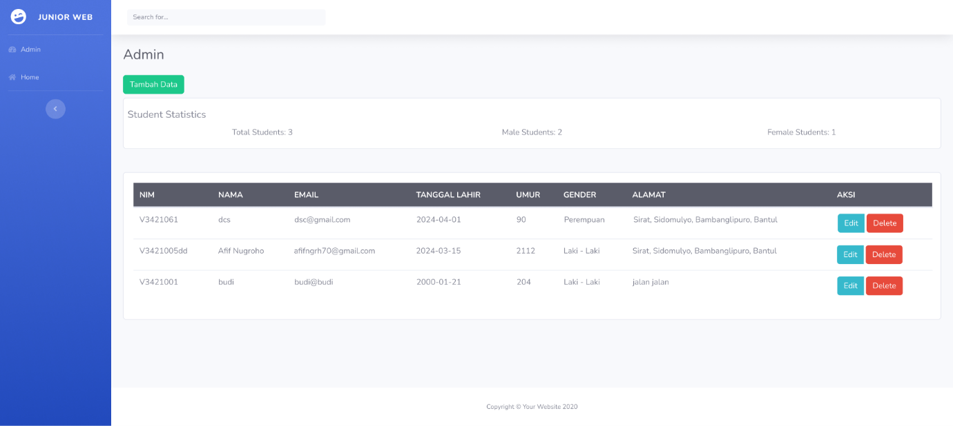

1. Halaman Home

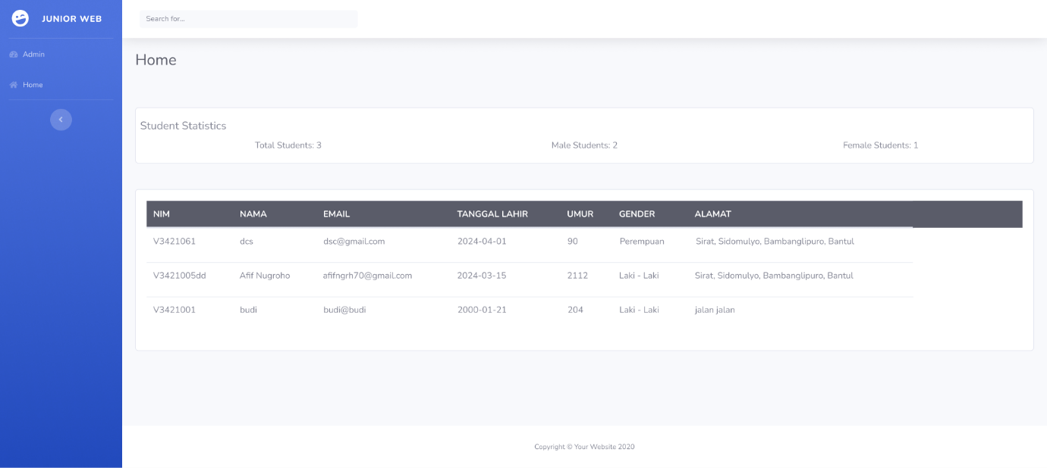

1. Halaman Tambah Data

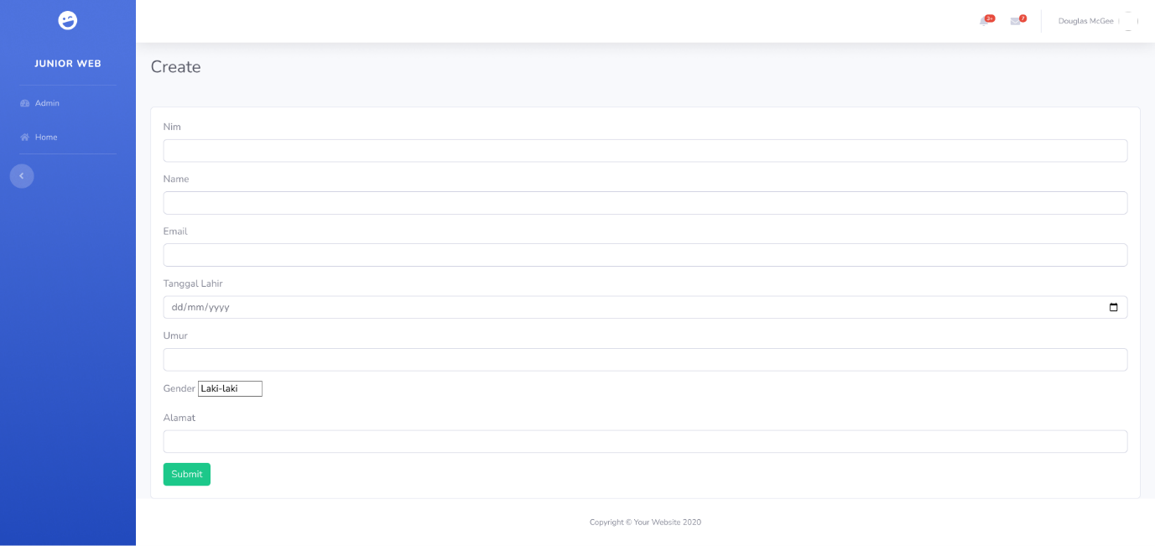

1. Halaman Edit

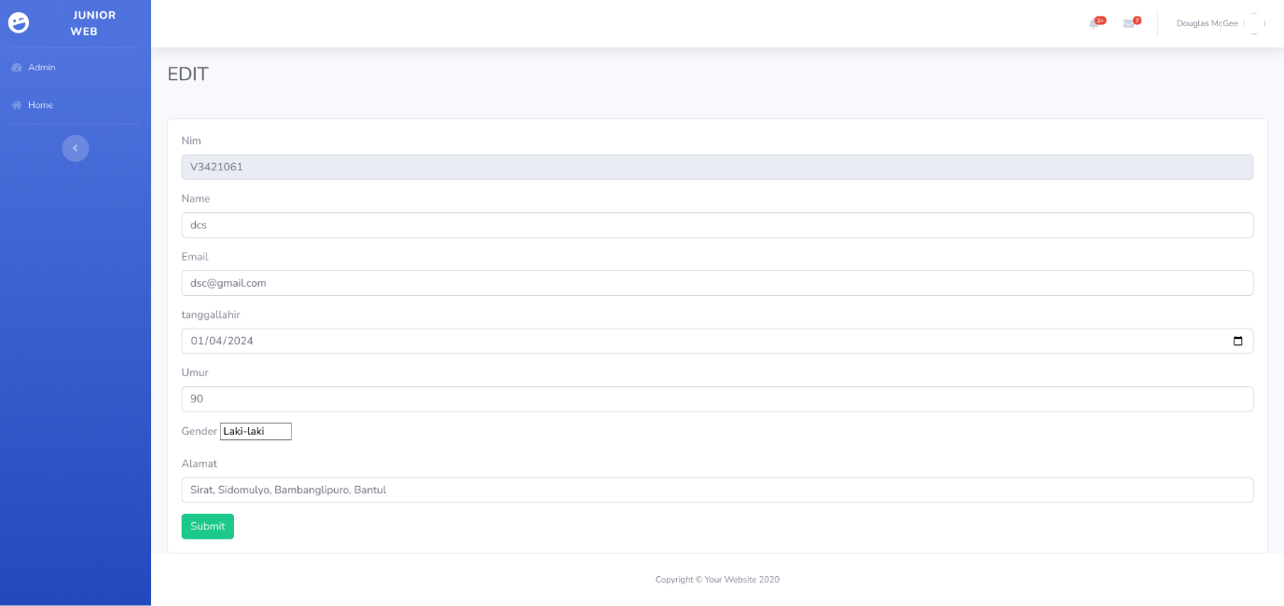

* Flowchart

1. Flowchart Create Data Mahasiswa

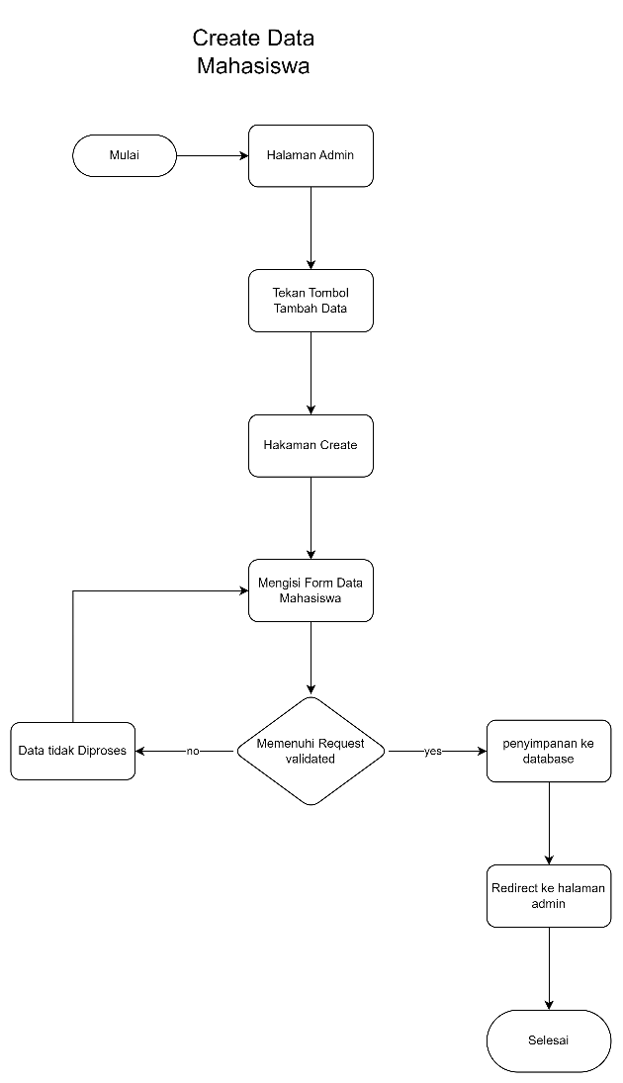

1. Flowchart Update Data Mahasiswa

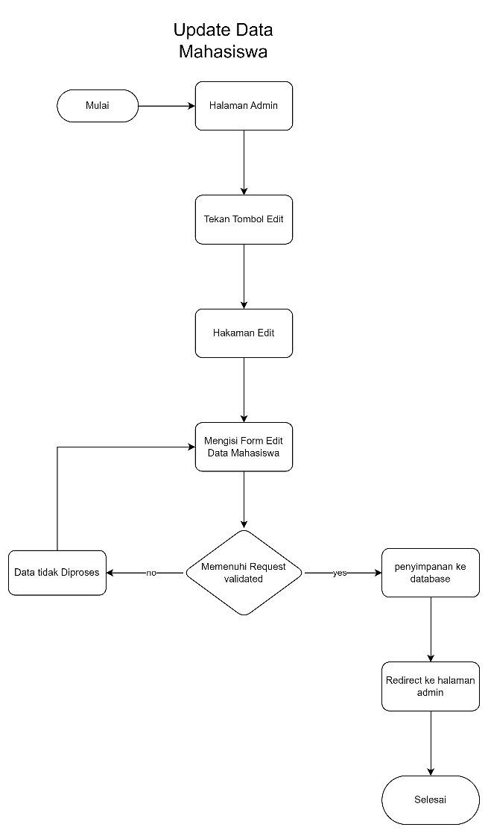

1. Flowchart Delete Data Mahasiswa

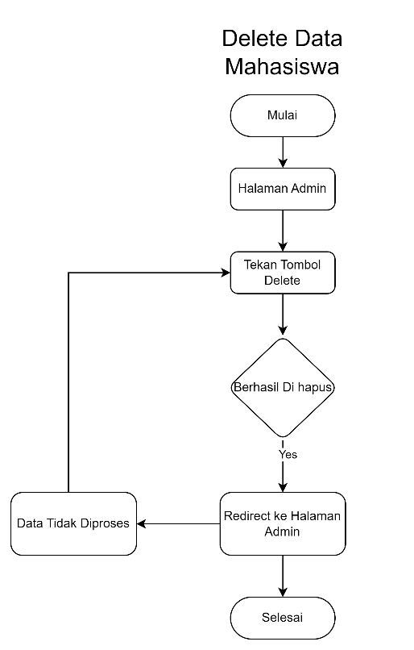

1. Flowchart Search Data Mahasiswa

